[](https://pharmacies.nhsforthvalley.com/)

Forth Valley Community Pharmacies Providing

Injection Equipment Provision Service (IEP)

|  |  |  |
| --- | --- | --- |
| FALKIRK | STIRLING | CLACKMANNAN |
| Falkirk Pharmacy  96-98 Grahams Road Falkirk | Cornton Pharmacy  54 Cornton Avenue, Cornton | Holm Pharmacy  130a Stirling Street  Alva |
| Denny Pharmacy  1 Stirling Street  Denny | Lindsay & Gilmour  15 Bannockburn Rd St Ninians | Alloa Pharmacy  Marshill  Alloa |
| Howard Pharmacy  29 La Porte Precinct, Grangemouth | Macfarlanes Pharmacy  48a Drip Road  Stirling | Lindsay & Gilmour  81 Main St Sauchie  Alloa |
| Larbert Pharmacy  94 main Street  Larbert | Plean Pharmacy  Braefoot, Main Street Plean |  |
| Callendar Pharmacy  316-318 Main Street, Camelon | Superdrug Pharmacy  Thistle Centre  Stirling |  |
| Boots Pharmacy  60 South Street, Boness | St Ninians Pharmacy  39 BannockburnRd, St Ninians |  |
|  | Right Med Pharmacy  The Square  Fallin |  |

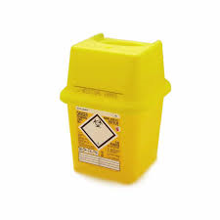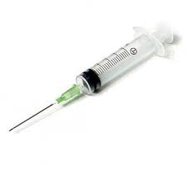

Please visit your local pharmacy for a user friendly, confidential service.