Community Pharmacy Development Team – FESTIVE BRIEFING

Merry Christmas and a Very Happy and Healthy 2023

Dear Community Pharmacy Teams

The following document has been produced to provide updates on a number of services and so you have information which we hope will be helpful over the festive period all collated in one place. We hope you find this information useful and would ask you to share widely with the whole community pharmacy team.

EMERGENCY CARE SUMMARY
If you require an account created to access the Emergency Care Summary or a password reset please email fv.ecscommunitypharmacy@nhs.scot.

MDS
Out of hours often report an increased number of patient referrals from 111 during bank holidays, often because they have forgotten to collected their weekly medication prior to a bank holiday, have not realised their supplying pharmacy will be closed or due to administration errors when a delivery has not been made by the pharmacy. Community Pharmacy Teams are asked to start planning now to ensure a process is in place to maintain continuity of supply over the festive period. This should include a mechanism to identify any uncollected MDS prior to pharmacy closures and every effort made to contact patients to ensure medication supply during the bank holiday weekends.

SUBSTANCE SERVICES
Please refer to the separate Substance Services festive communications.

UNSCHEDULED CARE
Community pharmacists are reminded that the Unscheduled Care PGD was updated several years ago to widen the inclusion criteria. This includes the following scenarios:
- Patient recently discharged from hospital with new medication and has not organised a further supply with their own prescriber who is now unavailable
- Acute prescribed medication that has been lost, stored incorrectly or smashed bottle.
- Medication that is prescribed regularly but may not be on a repeat prescription – for example antidepressants
- Patient has been prescribed an acute medication but prescription has not been forwarded/received in the pharmacy and prescriber unavailable – information held on ECS would enable supply
- Patient prescribed medication which they cannot swallow and they require a liquid preparation
- Alternative flavour of same antibiotic if child unable to tolerate dispensed medication or capsule/tablet formulation if this resolves the situation
- Supply alternative formulation is dispensed medication is not suitable for other reasons e.g allergy to excipient
- Acute supplies of rescue antibiotic for COPD patients, many patients keep rescue antibiotic but may have used the last one without renewing it
- Dispense remaining balance of antibiotic when original dispensing pharmacy is closed
Teams are reminded that patients do not need to provide evidence of a previous supply e.g packaging/repeat slip or request a supply from their usual pharmacy. If a pharmacist wishes to confirm the prescribed mediation this can be done by accessing ECS.

STOCK OF ANTIBIOTICS AND STERIODS
Community pharmacy teams are asked to review their current stock levels of antibiotics and steroids. Out of Hours have reported an increased number of patients presenting who require antibiotics and/or steroids. To ensure demands can be met please consider increasing your stock holding over the winter period.
CD INCIDENT FORMS/CD DESTRUCTION
We have been reviewing local processes and have identified that CD Incident Forms are not always completed by community pharmacies when a CD incident occurs. In particular if a pharmacy is alerted to an error involving a controlled drug by the Community Pharmacy Development Team as well as responding to the incident a form should also be completed and submitted to tricia.mckenzie@nhs.scot. Tricia can also be contacted if any out of date controlled drugs require destruction.

PCR/Generic mailbox
Please make sure staff have access to the PCR and Generic mailbox for the Pharmacy. These systems give the most up to date information and Clinical information you may need. If access is required please e-mail victoria.young@nhs.scot

MAT NEO 360
Please note the cut-off date for submitting NEO Mat claims is 10th of each Month.

STOP SMOKING
January is one of the most common times for smokers to attempt to stop smoking. Please see contact details below for support and information. Please feel free to contact one of the Stop Smoking Service Team for info regarding support for your patients.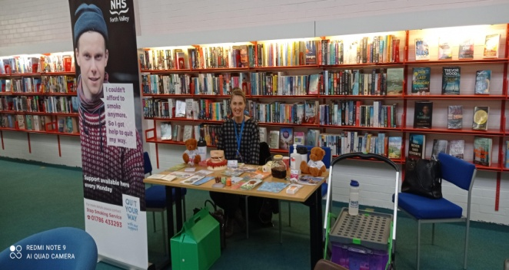

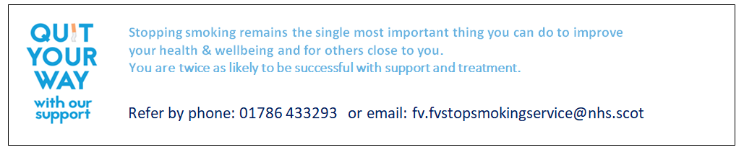

MOBILE PHONES/EMAILS
Mobile phones have been issued to the majority of pharmacy teams to support professional to professional communication. Please make sure these are switched on and charged. The generic nhs email account should be checked three times daily for important updates, if you require additional staff to have access please email cpemailrequests@nhs.scot and a member of the ICT Team will be able to help you.

