Forth Valley Community Pharmacies Providing
Injection Equipment Provision Service (IEP)
FALKIRK | STIRLING | CLACKMANNAN
Lloyds Pharmacy  96-98 Grahams Rd | Cornton Pharmacy  54 Cornton Avenue, Cornton | R & J Marshall  130a Stirling Street, Alva
Lloyds Pharmacy  1 Stirling Street Denny | Lindsay & Gilmour  15 Bannockburn Rd St Ninians | Lloyds Pharmacy  Marshill Alloa
Lloyds Pharmacy  29 La Porte Precinct Grangemouth | Lindsay & Gilmour  5 Firs Entry Bannockburn | Lindsay & Gilmour  81 Main St Sauchie, Alloa
Larbert Pharmacy  94 main St Larbert | Plean Pharmacy  Braefoot, Main St Plean
Lloyds Pharmacy  316-318 Main St Camelon | Superdrug Pharmacy  Thistle Centre, Stirling
Boots Pharmacy  60 South St Boness | Lloyds Pharmacy  39 BannockburnRd, St Ninians
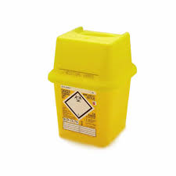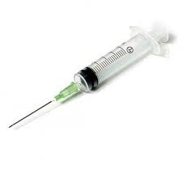
Please visit your local pharmacy for a user friendly, confidential service.

